ST. XAVIER’S COLLEGE

**(Affiliated to Tribhuvan University)**

**Maitighar, Kathmandu**



**DBMS**

**Lab Assignment #5**

**SUBMITTED BY**

**Suraj Nepal**

**013BSCCSIT042**

**4th sem/ 2nd year**

**SUBMITTED TO**

**Er.Sanjay Kumar Yadav**

**Lecturer**

**Department of Computer Science**

**St. Xavier’s College**

1. What do you mean by Entity- Relationship Diagram? Explain

Ans: An *entity relationship model*, also called an *entity-relationship (ER) diagram*, is a graphical representation of entities and their relationships to each other, typically used in computing in regard to the organization of data within databases or information systems. An entity is a piece of data-an [object](http://www.webopedia.com/TERM/O/object.html)or concept about which data is stored.

1. Define entity and give an example.

Ans: Entities are represented by means of rectangles. Rectangles are named with the entity set they represent.

Entities in a school database

An Entity can be any object, place, person or class. In E-R Diagram, an entity is represented using rectangles. Consider an example of an Organisation. Employee, Manager, Department, Product and many more can be taken as entities from an Organisation.

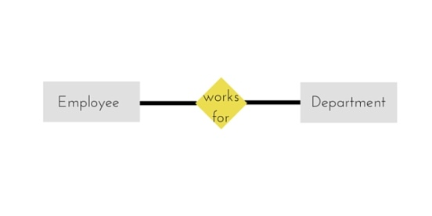

Weak Entity:

Weak entity is an entity that depends on another entity. Weak entity doesn’t have key attribute of their own. Double rectangle represents weak entity.

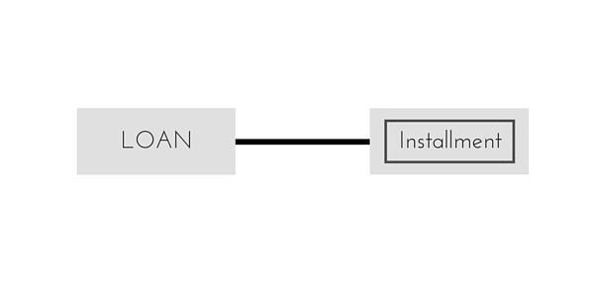

1. Explain the different between an entity class and an entity instance.

Entities are represented by means of their properties, called **attributes**. All attributes have values. For example, a student entity may have name, class, and age as attributes.

There exists a domain or range of values that can be assigned to attributes. For example, a student's name cannot be a numeric value. It has to be alphabetic. A student's age cannot be negative, etc.

Types of Attributes

* **Simple attribute** − Simple attributes are atomic values, which cannot be divided further. For example, a student's phone number is an atomic value of 10 digits.
* **Composite attribute** − Composite attributes are made of more than one simple attribute. For example, a student's complete name may have first_name and last_name.
* **Derived attribute** − Derived attributes are the attributes that do not exist in the physical database, but their values are derived from other attributes present in the database. For example, average_salary in a department should not be saved directly in the database, instead it can be derived. For another example, age can be derived from data_of_birth.
* **Single-value attribute** − Single-value attributes contain single value. For example − Social_Security_Number.
* **Multi-value attribute** − Multi-value attributes may contain more than one values. For example, a person can have more than one phone number, email_address, etc.

These attribute types can come together in a way like −

* simple single-valued attributes
* simple multi-valued attributes
* composite single-valued attributes
* composite multi-valued attributes

1. Define relationship and give an example.

The association among entities is called a relationship. For example, an employee works**_**ata department, a student enrolls in a course. Here, Works_at and Enrolls are called relationships.

1. Define degree of relationship.

The number of participating entities in a relationship defines the degree of the relationship.

* Binary = degree 2
* Ternary = degree 3
* n-ary = degree

1. List and give an example of the three types of binary relationships. Draw an E-R diagram for each.

Ans

A relationship where two entities are participating is called a binary relationship. Cardinality is the number of instance of an entity from a relation that can be associated with the relation.

* One-to-one − When only one instance of an entity is associated with the relationship, it is marked as '1:1'. The following image reflects that only one instance of each entity should be associated with the relationship. It depicts one-to-one relationship.

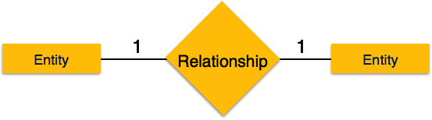

* One-to-many − When more than one instance of an entity is associated with a relationship, it is marked as '1:N'. The following image reflects that only one instance of entity on the left and more than one instance of an entity on the right can be associated with the relationship. It depicts one-to-many relationship.

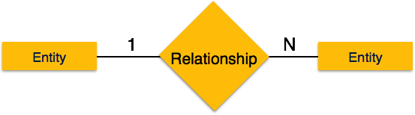

* Many-to-one − When more than one instance of entity is associated with the relationship, it is marked as 'N:1'. The following image reflects that more than one instance of an entity on the left and only one instance of an entity on the right can be associated with the relationship. It depicts many-to-one relationship.

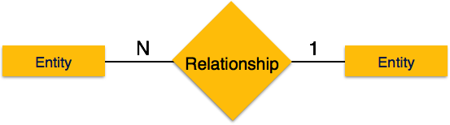

* Many-to-many − The following image reflects that more than one instance of an entity on the left and more than one instance of an entity on the right can be associated with the relationship. It depicts many-to-many relationship.

